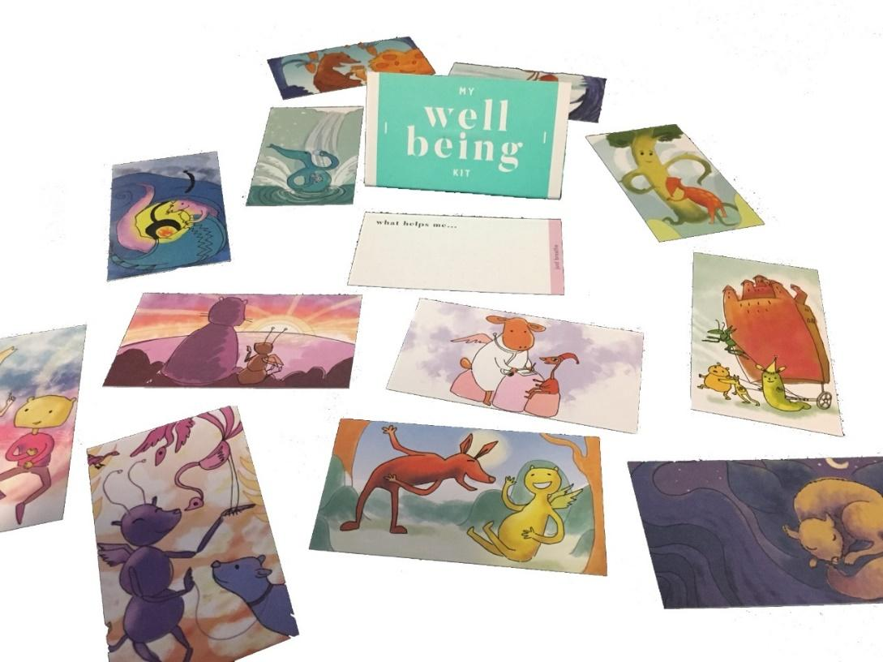

My Wellbeing Kit

Release Schedule

|  |  |
| --- | --- |
| Sam Fahey | Project Manager |
| Aidan Vos | Client Liaison |
| Changlai Zhao | Lead Artist/Interfacer |
| William Stephenson | Lead Programmer |
| WenHao Wang | Lead Programmer |
| Weibo Chen | Lead Designer |
| Sa Ma | Lead Designer |

# Table of Contents

**Table of Contents** **1**

**Overview** **2**

**1. Release One** **3**

1.1 Android Application 3

1.2 Wellbeing Cards 3

1.2.1 Wellbeing Card Descriptions 3

1.2.2 Editing and Deleting Wellbeing Card Descriptions 4

1.2.3 Favourite Cards 4

1.3 Journal System 4

1.3.1 Journal Entry Creation 4

1.4 Helpful Resources 5

**2. Release Two** **5**

2.1 Upgrading of Android Application Functionality 5

2.2 IOS Application Development 5

2.3 Wellbeing Cards 6

2.3.1 Wellbeing Card Duplication 6

2.4 Aesthetics and animations 6

2.5 Journaling System 6

2.5.1 Journaling System Categorisation 6

2.5.2 Journaling System Sort 7

2.5.3 Journaling Password Lock 7

2.6 The Emotional Bank 7

2.6.1 The Emotional Bank - ‘Tree of Words’ 7

2.6.2 The Emotional Bank - ‘Descriptor Prompt’ 8

2.7 Custom Cards 8

2.7.1 Add Custom Cards 8

2.7.2 Deleting Custom Cards 9

**3. Release Three** **9**

3.1 Adding Music 9

3.2 Customisation Options 10

# Overview

The My Wellbeing Kit Project will be developed in three major releases, each building upon the last, before implementing new components and expanding on existing functionality.

Release One will focus primarily on the creation of the code base and building blocks for the application. This stage of the development will include only an Android application. During Release One the application will only contain the most essential components for the application to perform basic functionalities such as; a navigable menu system, a user's ability to view, edit and write descriptions on the back of their Wellbeing Cards, create journal entries, automatic retention of the creation date for each journal entry and the implementation of the helpful resources page.

Release Two’s major objectives are to expand on the functionality of the Wellbeing Cards and the Journaling system from Release One and deliver a completed application, whilst also developing the same application but for the IOS operating system for use on Iphones. This means at the completion of Release Two the user will have the additional functionality of duplicating and deleting Wellbeing Cards, as well as creating custom cards. Editing and deleting entries will be made available within journaling system, sorting and categorising journal entries by ‘Keyword’ or date will also be implemented along with the added feature of password protecting your journal entries. The implementation of the Dictionary of Emotions (the Emotional Bank) will be created and installed through two major components; the ‘Tree of Words’ system and the ‘Descriptor Prompt’. Towards the end of Release Two finalisation of the application’s already installed components and aesthetics will take precedents. The navigational menus will be updated with final artwork, animations for user interactive feedback shall be implemented and the animation for the flipping of the cards will be installed and finalised. Finally simple features such as the colorblind mode will be added.

Release Three of the project will hold all components of the application that are not required but are seen as ‘nice to have’. By this time in the project all major components of the application will be completed and function to a professional standard. However if development should progress with minimal to no obstruction then the following components will look to be implemented; embedding music from sources such as Spotify into the Wellbeing Card system and custom preferences that will aid in providing a pleasant experience for the user by giving them the ability to adjust the applications interface.

# 1. Release One

The first release was an implementation period that took place over the span of four weeks. Release One included an Android application with basic functionality as a ‘proof of concept’ and a demonstration of its mandatory functions that the completed application will continue to expand upon. These elements were the ability to view and select all the existing Wellbeing Kit cards, write descriptions on the back of a selected card, edit card descriptions, select favourite cards, view all favourite cards, create journal entries and view a list of helpful resources. These were all the mandatory features that were included in this release.

## 1.1 Android Application

Development for release one consisted of an Android application. All application development was completed using the Android Studio integrated development environment (IDE) utilising a combination of the Java programming language and Extensible Markup Language (XML). The application featured a minimum API level of 14, Android Ice Cream Sandwich 4.0.1 - 4.0.2, allowing fo the targeting of a vast majority of Android devices. Developmental builds were tested throughout the implementation process on both virtual and physical Android devices running different versions of the operating system for compatibility.

## 1.2 Wellbeing Cards

The ability for the user to view a list of all the existing Wellbeing cards and interact with them by selecting an individual card was implemented. Upon launching the application, Wellbeing cards featuring their matching original artwork are now presented to the user. The application indicates that this list of cards is interactive ensuring the user is aware of the card’s basic functionality.

### 1.2.1 Wellbeing Card Descriptions

The user is prompted to enter a description on the back of each card after selection. Upon selecting an individual card, the user is taken to the back of the card From here the card can be written on with a short description relating to that specific card, with the option to save or discard their work upon completion. If the user chooses the save option, then the application will store the collected data locally. If the user opts to discard the description, the relevant data will be removed.

### 1.2.2 Editing and Deleting Wellbeing Card Descriptions

The Wellbeing Card system provides the user with the ability to edit and delete the descriptions on the back of their cards. This feature allows the user upon the creation of a card description to review and subsequently reword and rephrase their input. If the user is unhappy with a description they may remove their input entirely. Functionality like this is a necessity when working with text fields that utilise input from users. Incorporating a failsafe system that accounts for human error ensures that users are comfortable when filling in their card description fields.

### 1.2.3 Favourite Cards

The user is able to flag cards they consider their favourite for quick access in the future. After selecting a card from the list, the user is then able to indicate if this card should be considered a favourite by using a toggleable option. The application will then remember favourite cards and present them at the top of the list of Wellbeing Cards.

## 1.3 Journal System

Release one of the application added a feature to the basic journal system through which the user is able to write down a detailed description of their feelings or daily happenings. An option is present on the main menu screen titled “Journal” that upon selection will take the user to a list of their existing journal entries, providing an option to create a new entry. The application lists all saved journal entries and allow the user to view individual entries upon selection.

### 1.3.1 Journal Entry Creation

A “Create New” button is present on the journal screen in release one of the application. Selecting this button will take the user to the entry creation screen where they can write down detailed information, with the option to save their entry or discard it upon completion. The application will store saved entries locally on the device and present them on the journal screen, automatically keeping track of the date the entry was created.

## 1.4 Helpful Resources

Release one features a list of helpful resources and links provided by the Clarence City Council. Accessed via an option on the main menu titled “Helpful Resources”, the application takes the users to a screen containing helpful links and phone numbers, to which the user can add their own. Default options on the list interact with the phones existing applications for given operations, for example, phone numbers will open the dialler application with the number pre-filled and web links will open in the web browser application.

# 2. Release Two

Release Two’s most notable addition will be that of recreating the entire project for IOS devices. All functionality from the beginning of Release Two onward will be coded in tandem with one another; with first Android functionality being installed followed up with IOS. The Wellbeing Cards will receive additional functionality with the incorporation of the ability to duplicate cards. The Journaling system will receive the added functionality of categorising entries by ‘Keyword’, the ability to sort by date and ‘Keyword’ and the option to password protect your entries. New systems for the application will include the ‘Dictionary of Emotions (the Emotional Bank)’. This component will be delivered as two seperate subcomponents; the ‘Tree of Words’ and the ‘Descriptor Prompt’. Custom Cards will be implemented including all the functionality of the Wellbeing Cards with the additional ability to delete cards. Finally Release Two will encompass new design elements such as providing a user-friendly menu system.

## 2.1 Upgrading of Android Application Functionality

Coding for android devices will continue utilising the Android Studio integrated development environment (IDE) throughout Release Two of the project. All functionality in this stage will first be implemented for Android devices with the continued use of Java and XML.

## 2.2 IOS Application Development

Coding for IOS devices will commence in Release Two. During creation of the IOS application a combination of Swift, XML and HTML5 programming languages will be used throughout the process of re-implementation and for all further development. The use of XML in both Android and IOS applications will allow for some code reuse between platforms.

## 2.3 Wellbeing Cards

### 2.3.1 Wellbeing Card Duplication

The ability to duplicate Wellbeing Cards will give users the added benefit of creating different descriptions for the same card. Where a user may see an image one day and find themselves moved to write a description that could be categorised as ‘sullen’; the next day they may find their predisposition towards that card has change and categorise it as ‘thought provoking’. The user can now Instead of simply deleting the description for the card and rewriting it, duplicate the card and so keep both cards under different keywords. This option will be available to the user when viewing a Wellbeing Card through a ‘duplicate’ button located at the top of their screens. Once clicked a new dialogue box will appear asking the user “Do you wish to duplicate this card?.” Upon selecting ‘yes’ a copy of the original card will appear. This will be made visible by the introduction of a small coloured icon indicating to the user that this card is a duplication, not the original. Form here the user can write a new description for the card and categorise it under a different keyword.

## 2.4 Aesthetics and Animations

Throughout the continuation of the project, integration of new art work and animations will provide a level of professionalism as the application develops. Come the end of Release Two, icon choices, colour scheme and finalisation of layout for both Android and IOS applications will have been completed. .

## 2.5 Journaling System

### 2.5.1 Journaling System Categorisation

The Journaling system in stage two of the project will be given the ability to categorise entries by ‘keyword’. This functionality will be made available to the user through the a simple ‘categorise’ button located near the top of the every new entry form. Onclick of the button the user will be provided with a new dialogue box in which they can input an keyword of their choosing. Should the user for example input the word “inspiring” as their chosen ‘keyword’, all journal entries categorised with the same ‘keyword’ will be lumped together allowing the user when sorting through their entries to quickly locate all entries under a given category.

### 2.5.2 Journaling System Sort

The sort functionality will be created in stage two of the project and will be added to the journaling system as a way for the user to speed up the process of finding journal entries. Upon opening up the Journal system from the main menu users will be met with a screen listing all their previous journal entries. Located at the top of the journaling screen, above the list of entries, will be a single drop down menu. Two options will be made available through the drop down menu; sort by date and sort by category. As both names suggest the user will have the ability to either sort by ‘keyword’, organised by most recent first, or by the date it was created.

### 2.5.3 Journaling Password Lock

The password feature for the Journaling system will be a toggleable option available to the user through the system settings screen. When enabled the user will be asked by the application to input a password, re-confirm their password and also create a security question. Once the password system has been set up opening up the users journal entry will prompt the user to input a password. Passwords will be hashed and saved locally on the device. Passwords that do not match will not grant the user entry to the journaling system. If the user enters their password incorrectly three times they may also attempt to reset their password. This is accomplished by answering their security question. Password protection is a surefire way to ensure security for those who wish to record personal information and will help provide the user with peace of mind.

## 2.6 The Emotional Bank

### 2.6.1 The Emotional Bank - ‘Tree of Words’

The Emotional Bank feature will be split into two components. The first of these two components will be the ‘Tree of Words’. This is a stand alone feature within the application that will help the users to expand their vocabularies by learning new words. The Tree of Words functionality will be available to the user through the main menu by the use of the ‘Tree of Words’ button. Opening up this system will present the user with a list of very general words, such as ‘happy’, ‘sad’, ‘angry’, etc. Upon clicking on one of these words the ‘tree’ will expand using the users selection as the root word. The root word chosen is used to create new branches for the tree by delivering synonyms based off the users choice. Everytime the user selects a new word the tree will expand continually providing the user with new synonyms based upon their word choice. This framework gives the user a fun an interactive way to learn new words which will help them better describe their thoughts and feelings.

### 2.6.2 The Emotional Bank - ‘Descriptor Prompt’

The second component within the Emotional Bank system will be the ‘Descriptor Prompt’. This functionality will lie underneath and accompany both the Wellbeing Card and Journaling systems. The ‘Descriptor Prompt’ will be used by the application as a way to help coax users into expanding their vocabulary while writing descriptions for Wellbeing Cards or when creating Journal entries. This functionality will be made available as a toggleable option within the system settings. Toggling the Description Prompt ‘on’ will initiate a predictive text like framework. When a user inputs a word that lacks depth such as ‘happy’, ‘sad’, ‘angry’ the application will prompt the user and suggest alternatives such as “perhaps you meant... ecstatic, melancholy, enraged”. These prompts, just like predictive text prompts in texting and messaging mobile applications, will be inserted into the Wellbeing Cards and Journaling systems just above the users on-screen keyboard. Description Prompt will allow the user a efficient way to find and use alternative word when using the application, helping to better describe their thoughts and feelings.

## 2.7 Custom Cards

### 2.7.1 Add Custom Cards

Custom Cards will be a great feature that will be made available in stage two of the projects development. The option to create a Custom Card will be accessed through the main menu where upon the user selects the ‘create your own card’ button they will be brought to the Custom Card creation screen. Here the user will be prompted to upload an image and write a title for their card. Once the users choices have been finalised any card created will here will join the default Wellbeing Cards within the Wellbeing Cards system.

Adding custom cards is a great way to engage the user and insure that each individual's kit is made unique.

### 2.7.2 Deleting Custom Cards

Release Two will see the user able to delete custom cards. Were as the default Wellbeing Cards may not be deleted a custom card has this ability. To delete a Custom Card a user can browse to their ‘Wellbeing Cards’ and when on this display press and hold down a card. When held down for approximately 2 seconds a new dialogue box will appear asking the user “Do you wish to delete this card - The card and it’s description will be erased permanently.”

Upon selecting ‘yes’ the card will be removed from the application along with any description that may have been written on the back. Duplications of this card will not be erased. The user will not be permitted to remove the default set Wellbeing Cards.

# 3. Release Three

The third release of the My Wellbeing Kit application intends to expand upon the core features implemented in release two. This includes features identified during requirements elicitation that are not in the scope of the project and are therefore seen as ‘nice to have’ but not mandatory. Such features include; the ability to integrate music from popular media platforms such as Spotify and Apple Music directly into individual Wellbeing cards and the addition of several customisation options regarding the applications user interface.

## 3.1 Adding Music

A ‘Music’ button will be available whilst creating or editing a Wellbeing card allowing the user to embed a song of their choosing directly into the card using their preferred media platform (Spotify or Apple Music). The first time the option is selected the user will be taken to an external link in the devices web browser and prompted to sign into the service of their choice. A selected song is playable from within the My Wellbeing Kit when viewing a card, however the parent application (Spotify or Apple Music) must be installed for music to play.

## 3.2 Customisation Options

Several application customisation options will be available for the user to adjust the applications interface and overall experience to their personal preference. Customisation options are accessible through a settings option on the main menu screen. Users can select options to, change the colour theme of the user interface, enable/disable animations and enable/disable audio cues. Upon saving the settings via button located at the bottom of the screen, the application will close and relaunch with the specified parameters saving the current state as default for future use.